Military Institute of Science and Technology

Department of Computer Science and Engineering

Course Title: Data and Tele-Communication Sessional

Course Code: CSE-318, Cr. Hr: 1.50

Level-3, Term-2

**Experiment No: 10 Phase Shift Keying**

Updated on 16 August 2016

**Objective:**

To Study the basic operation of Phase Shift Keying (PSK)

**Theory:**

In Phase Shift Keying, the phase of the carrier sine wave at the transmitters output is switched between 0˚ and 180˚, in sympathy with the data to be transmitted, as shown in figure 1 below:

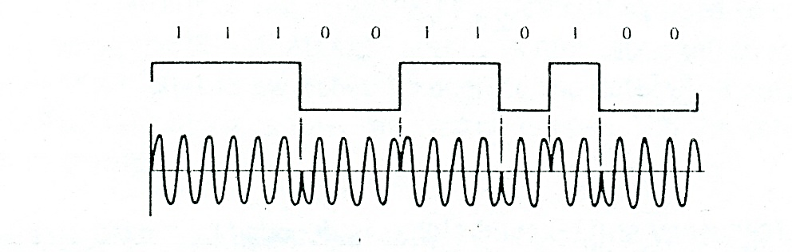

Figure 1

The functional blocks required in order to generate the PSK signal are similar to those required to generate an ASK signal. Again, a balance modulator is used, with a sinewave carrier applied to its carrier input for PSK generation, however, the digital signal applied to its carrier input. In contrast to ASK generation, however, the digital signal applied to the modulation input for PSK generation is bipolar, rather than unipolar, i e. it has equal positive and negative voltage levels.

When the modulation input is positive, the modulator multiplies the carrier input by this constant positive level, so that the modulator`s output signal is a sine wave which is in phase with the carrierinput. When the modulation input is negative, the modulation multiplies the carrier input by this constant negative level, so that the modulator`s output signal is a sine wave which is 180˚ out of phase with the carrier input.

The result is that the sinewave at the modulators output is inverted in phase every time the modulation input changes in polarity. The circuity required for generation of the PSK signal is shown in Figure 2 below.

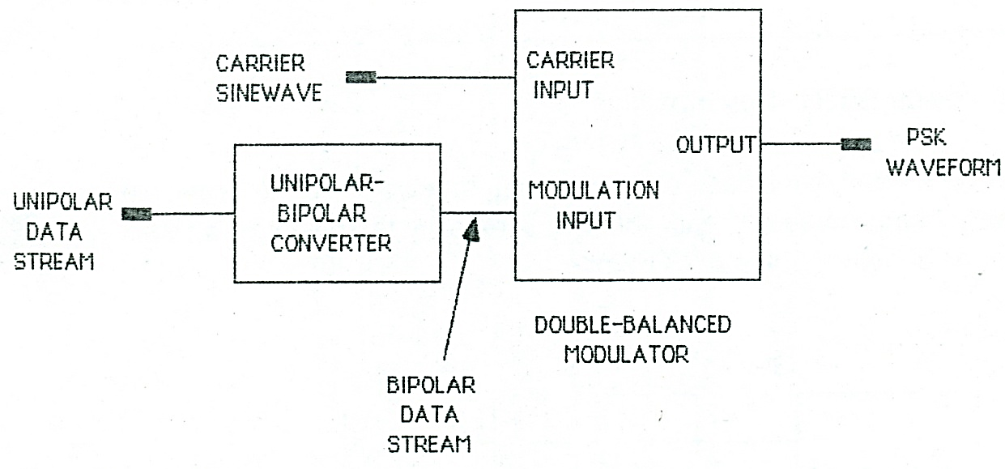

Figure 2

Note that a unipolar- bipolar converter is used to convert the original unipolar data stream into bipolar form.

At the Receiver, the Phase Shift- keyed signal is decoded by means of a Squaring Loop detector. This PSK Demodulator is shown functionally in Figure 3 below:

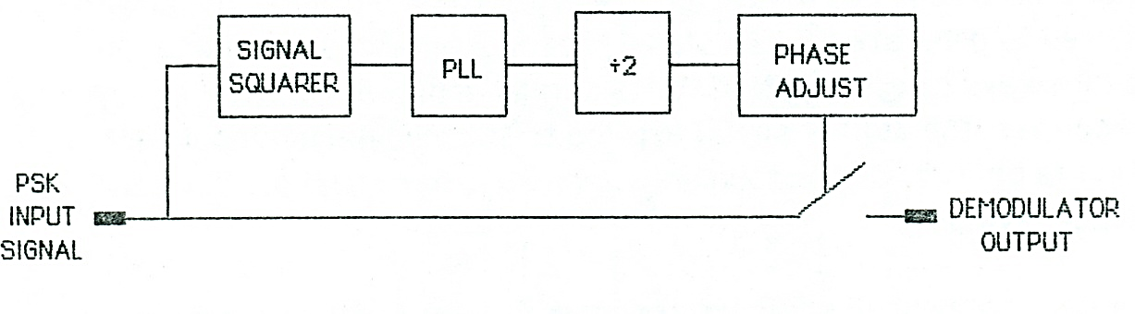

Figure 3

The incoming PSK signal, with its 0˚and 180˚ phase changes, first goes to the input of a signal squarer, which multiplies the incoming signal by itself (the signal squarer is basically a balanced modulator whose inputs are connected together). The output form the signal squarer is a therefore a signal at twice the original frequency, with phase changes of 0˚ and 360˚. Since a phase change of 360˚ is equal to one of 0˚ (i.e. no phase change at all), the signal squarer simply serves to remove the phase transitions from the original PSK signal.

The next stage of the PSK detector is Phase –locked loop (PLL), which locks on to the signal squarer`s output signal, and produces a good, clean square wave at the same frequency.

Since this frequency is currently twice that of the incoming PSK signal (because of the signal squarer’s operation), the next stage is to divide the frequency of PLL’s digital output by a factor of 2, so that the frequency is the same as that of the PSK signal. This is done by the ˖ 2 circuit.

The following stage is the PHASE ADJUST circuit, which allows the phase of the digital signal to be adjusted, relative to the original PSK input signal.

Finally, the output of the PHASE ADJUST circuit is used to control an analog switch .When the PHASE ADJUST output is high, the switch is closed, and the original PSK signal is switched through to the detector’s output. When the PHASE ADJUSTS output is low, the switch is open, and the detector’s output drops to 0 volts.

If the phase of the signal controlling the analog switch has been set up correctly, the demodulators output will contain only positive half –cycle when the PSK input has one phase, and only negative half –cycle when the phase is reversed.

The average level of the waveform at the PSK Demodulator’s output now contains information about the original data stream, so the next stage is to extract this average level by low-pass filtering.

The filters output appears as a very rounded version of the original data stream and is steal unsuitable for use by the receiver’s digital circuits. The overcome this the filters output wave form is squared up by a voltage comparator.

Note that the PSK demodulator has no way of knowing which of the incoming phases is 0˚ and which is 180˚. This leads to a phase ambiguity at the receiver since the final dat stream may either be the original transmitter data stream, or its inverse, depending on which of the incoming phases is taken to be 0˚.

The overcome this phase ambiguity, the original NRZ(L) data stream is first encoded in NRZ(M) signal that is then used to switch the phase of the carrier.

At the receiver the digital output from the comparator can once again take on one two forms one being the logical inverse of the other. However, since the original data was been encoded in NRZ(M) format, the absolute level of the receiver data stream is no longer important. The receiver simply needs to look for changes in level; a level changes representing in a ‘1’ and no level change representing a ‘0’. As a result the ambiguity in the received data stream is no longer a problem.

The check for changes in level is done by a differential bit decoder in the receiver which simply outputs a ‘1’ when a level change is detected and a ‘0 when no level change occurs. The resulting output from the differential bit decoder is therefore the original NRZ(L) data stream generated by the transmitter.

Figure 4 below shows the functional blocks required

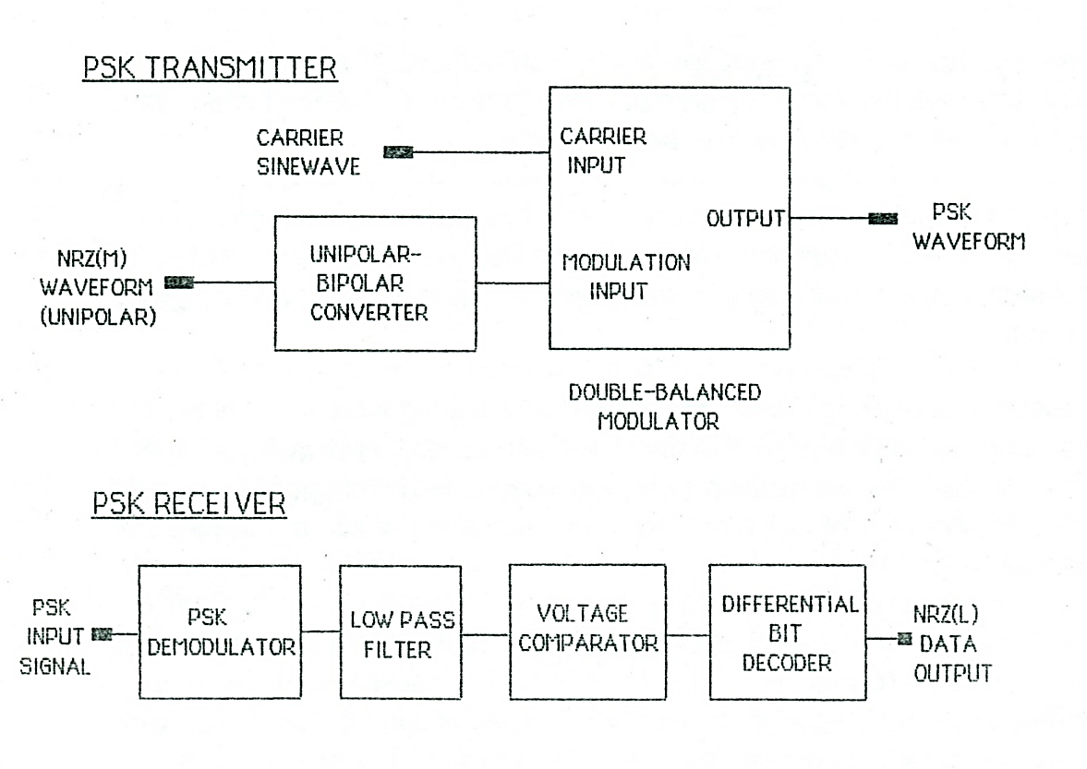

Figure 4

**Procedure:**

Practical Exercise-PSK- Phase Shift Keying

This practical exercise uses the boards MODICOM 3/1 and MODICOM 5/1 as the transmitter and the boards MODICOM 5/2 and MODICOM 3/2 as the receiver.

If necessary, check that MODICOM 3/2’s Clock Regeneration Circuit is set up for correct operation. See Appendix 1 for how and when to do it.

* Set up the MODICOM 3/1 board as follows:

Mode switch set to fast

Sync Code Generation switch to OFF

Error Check Code Selector switches to A=0 and B=0

Switched Faults- all switched OFF.

* On the MODICOM 5/1 board, check that the MODE switch is Set to position 1.
* Set up the MODICOM 3/2 board as follows:

Mode switch set to fast

Pulse Generator Delay Adjust –fully clockwise

Sync Code Detector switch to ON

Error Check Code Selector switches to A=0 and B=0

Switched Faults- all switched OFF.

* Connect the +5 volt, +12 volt and the -12 volt supplies to the boards and link their zero volt connections as shown in Figure 5 overleaf.
* Make the following connections:

MEDICOM 3/1Tx Clock Output tp3 to MEDICOM 5/1 Tx Clock Input.

MEDICOM 3/1 Tx Data Output tp44 to MEDICOM 5/1 Tx Data Input.

* On MEDICOM 3/1,connect the DC1 output on the function generator block to the Channel 0 input tp 10 and then a wire from this point to channel 1 input tp 12.
* On Modicom 5/2 selects 960KHz in the PSK Demodulator Circuit.

We can now supply the same DC voltage level to each of the channels.

Remember that the two channels are going to be multiplexed by TDM.

* Switch on the power supply.
* On MEDICOM 3/1 Adjust the DC1 preset until the A/D Converter LEDs show the value:

D6 D5 D4 D3 D2 D1 D0

0 1 0 0 0 1 1

* Connect your oscilloscope’s external trigger input to MEDICOM 3/1 `s TxTo Output signals at tp4 and switch the oscilloscope to external, negative edge triggering.
* Use your oscilloscope to observe the Data Clock output at tp4. In Modicom 5/1’s Data Conditioning block.
* Switch off the power supply.
* Make the following connections:**On MODICOM 5/1**
* Carrier input on Modulator 1 tp28 to the 960KHz(I) carrier tp26

Modulator 1 input tp29 to DC1 supply on MODICOM 3/1.

* Switch on the Power supply
* Use your oscilloscope to examine the Modulator output tp30 and also the DC level on tp29. Use the preset to vary the DC and look carefully at the sinewave and notice how the sinewave inverts as the DC level to the modulator moves negative to zero volts.
* Switch off the power supply.
* Now disconnect the DC input to tp29.
* Make the following connections:

On MODICOM 5/1

NRZ (M) output tp6 to Unipolar- Bipolar Converter input tp13

Unipolar- Bipolar Converter output tp14 to Modulator 1 input tp29

Modicom 5/1 to Modicom 5/2

Modualator 1 output tp30 to PSK Demodulator input tp10

**On Modicom 5/2**

PSK Demodulator output tp15 to Low Pass filter 1 input tp 23

Low pass filter 1 output tp 24 to Comparator 1 input tp 32

Comparator 1 output tp 33 to Bit Decoder input tp 32

**Modicom 5/2 toModicom 3/2**

Bit Decoder output tp39 to Rx data input tp1

Bit Decoder output tp 38 to Clock Regenerator input tp3

Clock input of Bit decoder tp 40 to Clock Regeneration circuit output tp8

**On Modicom 3/2**

Clock regeneration circuit output tp8 to Rx clock input tp46

* Switch on the power supply
* Use your double beam oscilloscope to observe the Bipolar Modulation input to Modulator 1 tp29 and the output wave form at tp30.
* There are three presets associated with this circuit that may need adjusting.
* Modulation offset. Adjust this to give equal signal level during the two states.
* Carrier offset adjust to give both phases a DC offset of zero volts.
* Gain. Adjust this to give a 2 volt peak to peak voltage waveform.
* You should now have a PSK waveform similar to that in figure 1

Demodulation

* Keep one of your oscilloscope probes on the Modulator 1 output tp30 to enable you to see the PSK waveform. The other probes can be used to see the PSK Demodulator output at tp15. Try adjusting the phase-adjust preset and observe the effect it has on the waveforms.
* In your workbook make a sketch of PSK waveform and beneath it, draw the PSK Demodulator Output. Notice that the data is recognizable but there is a large high frequency component present.
* Look at the output of the low pass filter and sketch it in your workbook. The high frequencies have been removed but it’s far from square.
* Check the output of the comparator and record this in your workbook

The Complete System

* On MODICOM 3/1 switch ON the Sync Code Generator and note that it’s A/D converter is now copied on the D/A converter of MODICOM 3/2. We will again try the whole system and the Multiplexing.
* On MODICOM 5/1 disconnect the inputs to channel 0 and Channel 1 from DC 1 and connect, instead, one channel to 1kHz signal and the other channel to the 2KHz signal.
* Switch your oscilloscope to internal triggering.
* Use your double beam oscilloscope to monitor both channel outputs on MODICOM 3/2 (tp33 and tp36). Notice that, once again, channels are quite independent – there should be no interference between the two waveforms and the amplitudes are each controllable by turning the associated presets. However, any interference which may be present can be eliminated by adjusting the Pulse Generator Delay Adjust preset.

**Pre Lab Questions:**

* (a) What is PSK? Explain the operation of PSK with necessary block diagram and output waveforms.
* (b) What are the applications of PSK?

**Post Lab Questions:**

* (a) Why the digital signal applied to the modulation input for PSK generation input is bipolar?
* (b) Draw the block diagram of the PSK transmitter and explain it`s operation.
* (c) Draw the block diagram of the squaring loop detector and explain the operation of each block.
* (d) Draw the PSK receiver block diagram and explain its operations.

**Conclusion and Discussions:**

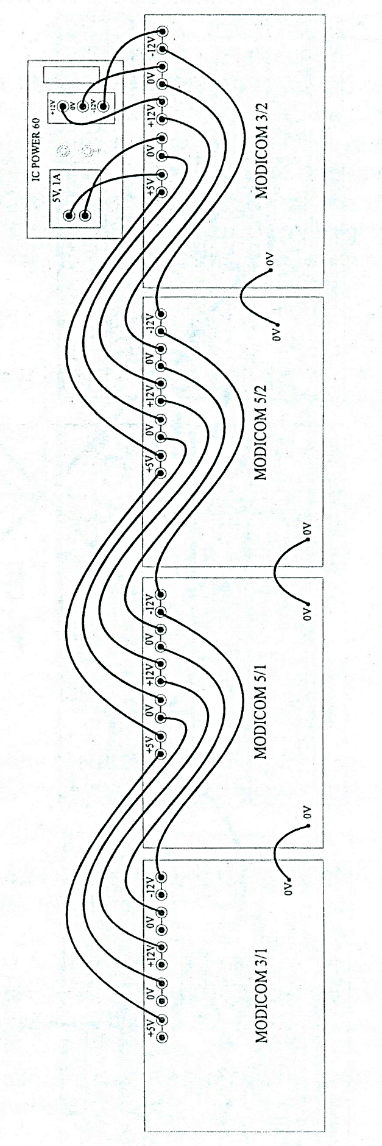

Figure 5

